1. 
2. 
3. 
4. 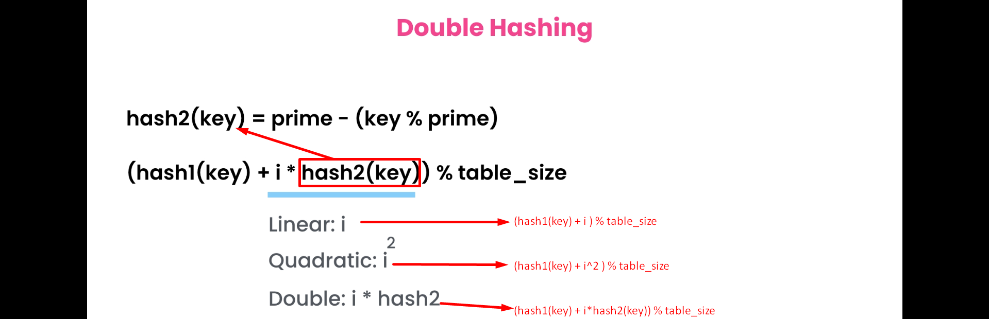
5. We don’t know from where this double hashing formula came but the experts say it works fine.
6. 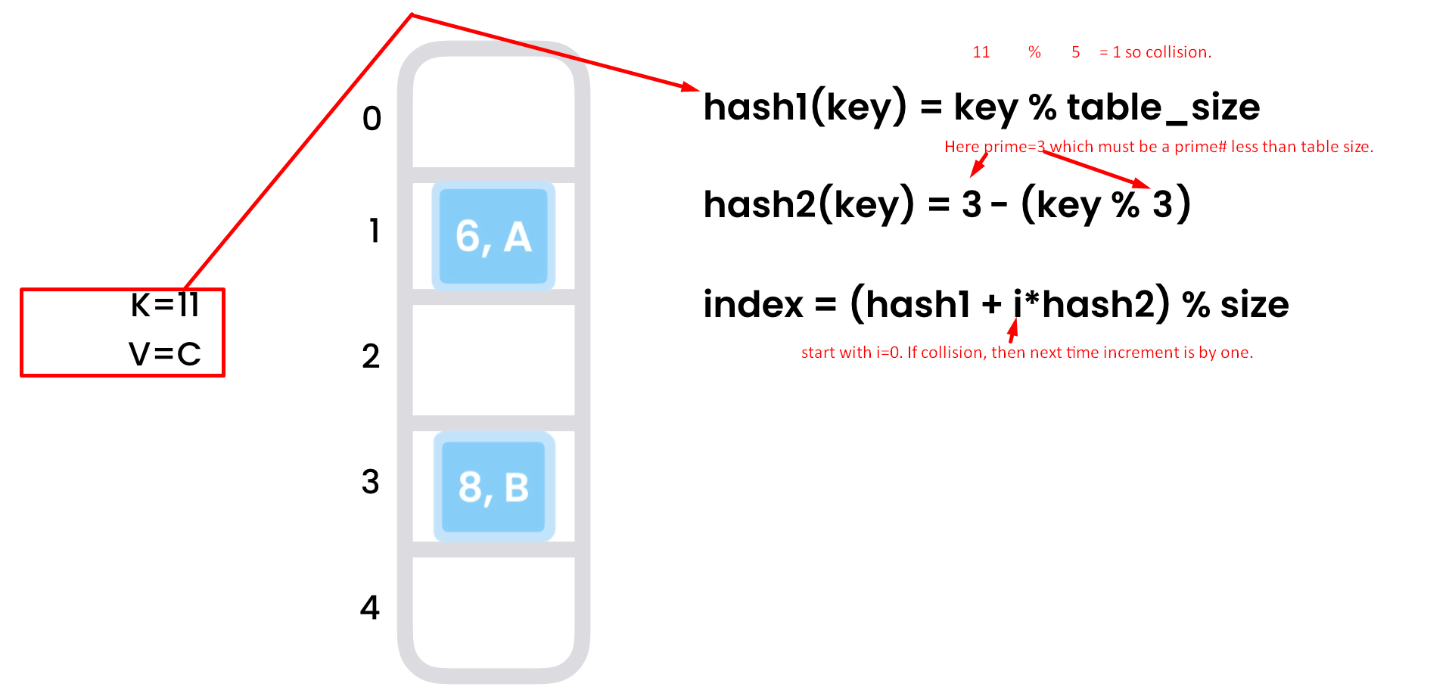
7. 